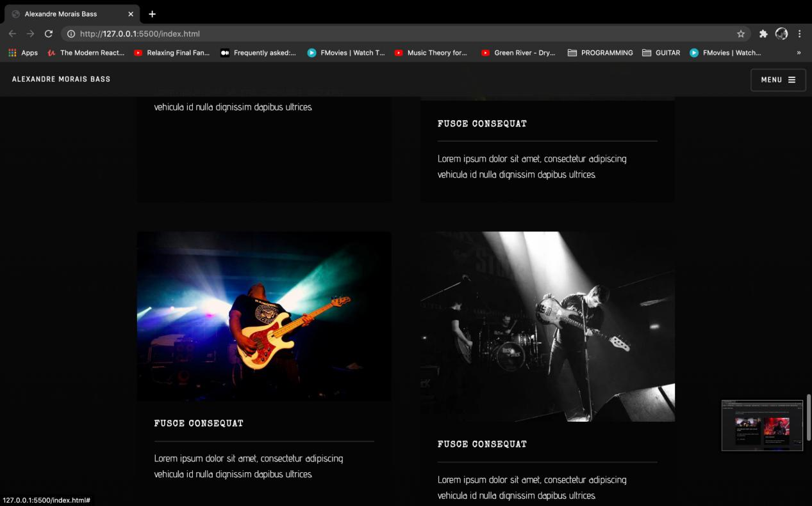

**Stage Driven**

**Since 97 playing live in small venues or big stages the live act is always part of my nature and my fellow musicians!**

**Partners in crime:**

**Master Ji,Gilbert´s feed band,Sonya Costa,Akunamatata, Né Ladeiras, Gonzo,P´laguita, Money Makers,Seattle, Rock em Stock,Tara Perdida,Toy and Mystic Hogs among so many others bonafide artists with the precious collaboration of labels and agencies made my dreams possible:Playing live and live from and for the STAGE!**

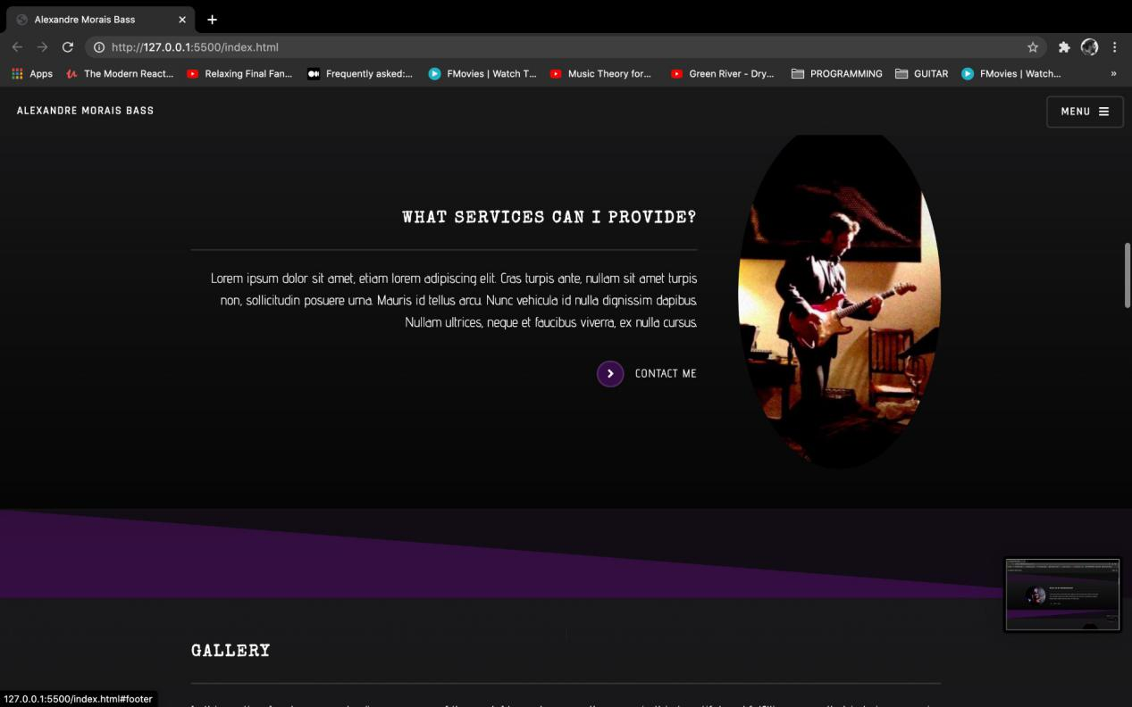

**Call me any time!**

**Guitar/bass private lessons? Harmony or theory?**

I taught in several schools throughout my journey as a music teacher. From head of the music department and music teacher in **Santo Antonio International School** or guitar and theory teacher in **Musicland I have** experienced different challenges as a teacher and even as a form tutor dealing with students from all different ages!

And its gets funnier and better every new challenge as they come around!

Currently i teach several private students and teach a guitar course in **St. James School** where music is a valued subject and students get a lot from it!

**Guitar stems? Bass Stems?**

Email me! I got different budgets to fit your project!

From my private studio to my official partnership with Red Alert Studios I´m committed to find the guitar or bass line you need and suites your project exploring different aesthetics and styles from punk to reggae, from metal to pop, from jazz to hip-hop.....you name it!

If you want a fretless line, an analog synth bite from Electro Harmonix or a 5 stringer Low end, your creativity and need is the limit!

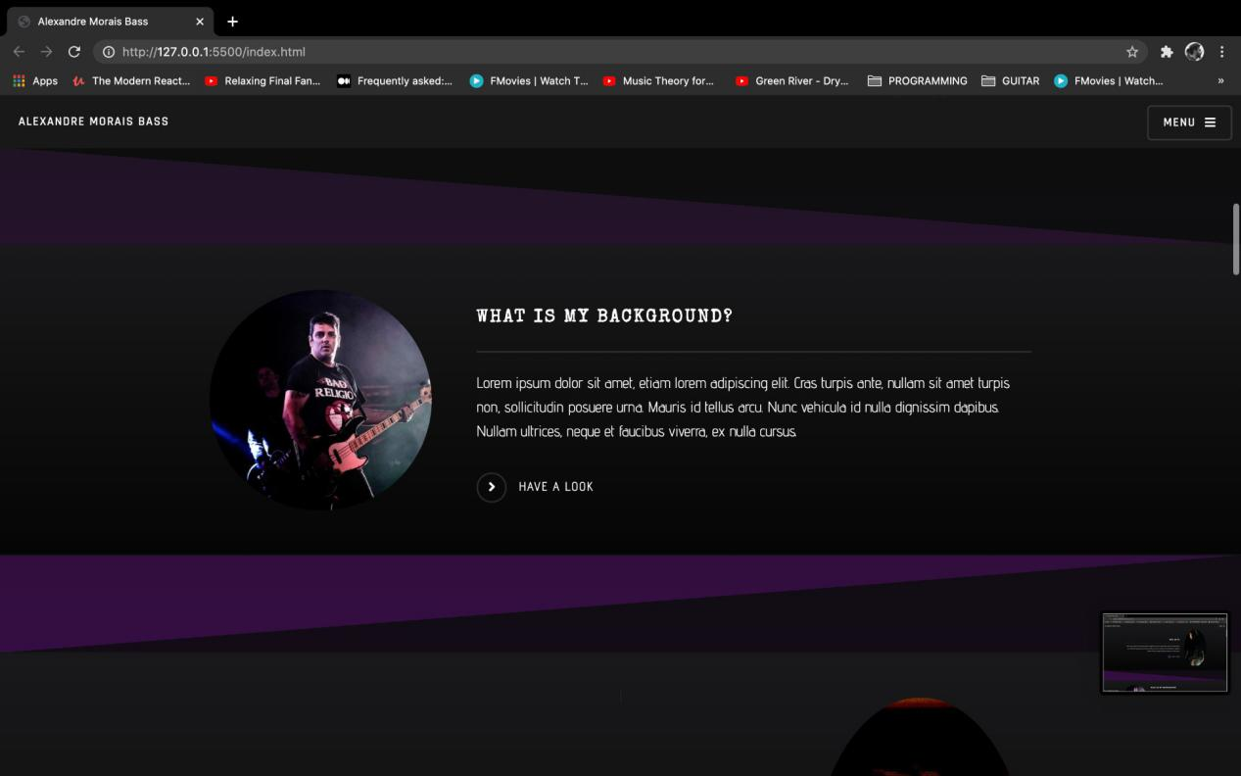

**What is My Background:**I´m a proud student of different gigantic teachers!Miguel Teixeira, Walter Lopes, Luís Moreno and Fernando Rui Amaral were my guitar teachers.

In the Lisbon Conservatório Nacional de Música I studied Cello with the great cello master Andrej Michalczyk. Then I studied with Luis Sá Pessoa in the school of the Lisbon metropolitan Orchestra having the privilege of pursuing my cello journey with private tuition with Miguel Rocha and Marina Freitas.

I Studied Jazz in Escola de Jazz do Barreiro for 3 years and then I had the opportunity to take private lessons with so many friends and excellent teachers like Massimo Cavalli, Yuri Daniel, Nuno Allan, Paulo Neves, Rui Teixeira (Double Bass), Guto Lucena, António Palma, Jorge Moniz, Miguel Barrosa, João Maurilío, Mário Delgado,Demian Cabauld just to name a few!

Since Music is an ongoing process of discovery I wish to meet as many gurus and learn as much as I can!

Never to old to learn more!

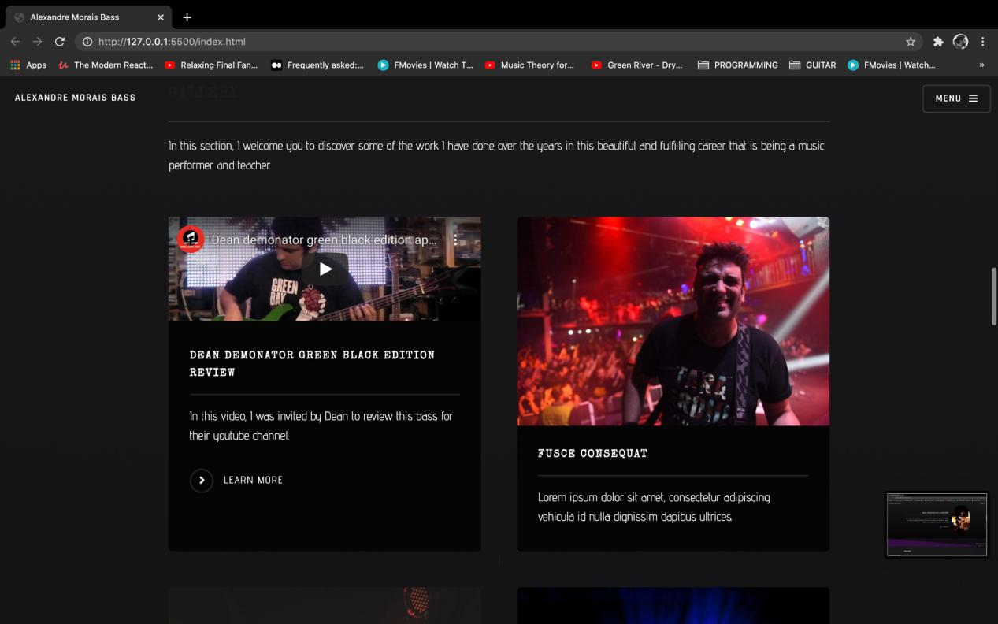

AlexSaysMusic

This is my youtube and facebook project where I provide

my students and general public some reviews, music, original compositions,exercises and other topics related to music our passion! Fun and with no pretension boys will be boys!

**Making Music is my business and business is good!**

Public! Crowd! People that breed Music Like me are the people I want to meet!

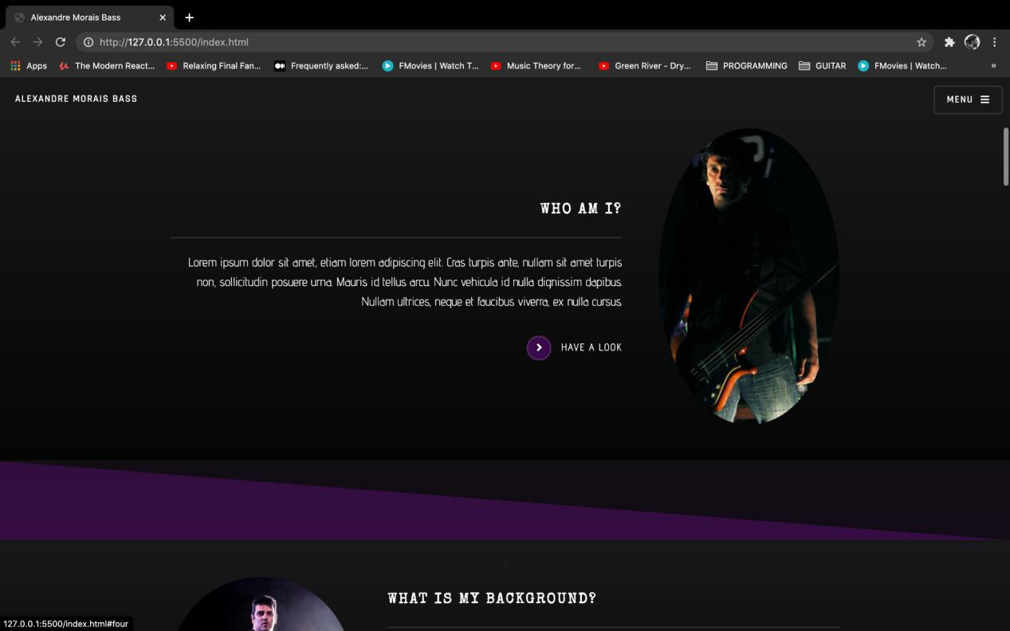

Who Am I?

I am, We are Musical beings! Nor black, nor white, purple or yellow just an human who loves Music!